The United Kingdom
EXIT TICKET 3 – 2 - 1
Before you leave class today, answer the following questions.
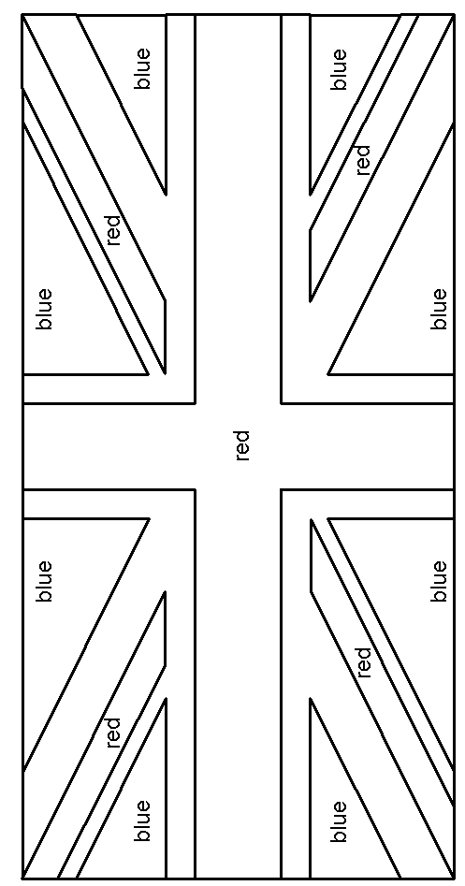
My name: __________________________________________
3 things I learned today

2 things I'd like to learn more about

1 question I have

Colour the flag of the United Kingdom!
THE UNION JACK

